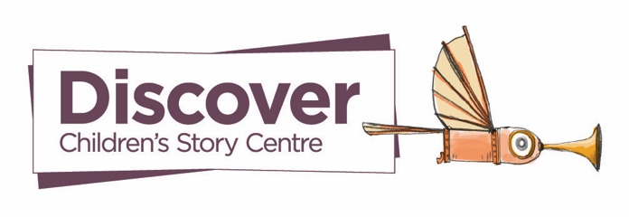
Discover, Children’s Story Centre | CPD For Educators Booking Form
Thank you for your interest in booking a CPD session visit offered by Discover.
Please kindly fill in the form below, email to bookings@discover.org.uk, and someone from our team will get in touch shortly. Thank you!
- Name, your role at the school and email address
- Name of the school
- Address of the school
(Please note: If the school is more than 10 miles from Discover, an additional £25 will be charged to cover travel costs. For schools outside of London, bookings must be for a full day, and the school will need to cover any reasonable travel expenses.)
- Choose from these two areas of focus: Story Building Methodology or SEND Sensory Storytelling
- What age range do you teach, EYFS, KS1, KS2, or a mix?
- How many educators will be attending the session? (30 max capacity)
- When would you like us to visit?
(Please provide specific months/weeks and if not, a range of available dates)

