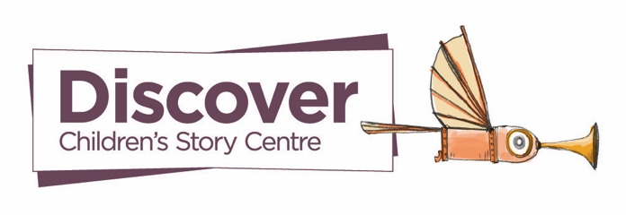
Discover, Children’s Story Centre | Old Mac’s Melodies Booking Form
Thank you for your interest in booking a Old Mac’s Melodies visit offered by Discover.
Please kindly fill in the form below, email to bookings@discover.org.uk, and someone from our team will get in touch shortly. Thank you!
- Name, your role at the school and email address
- Name of the school
- Address of the school
(Please note: If the school is more than 10 miles from Discover, an additional £25 will be charged to cover travel costs. For schools outside of London, bookings must be for a full day, and the school will need to cover any reasonable travel expenses.)
- How many full-day visits would you like to book?
(Please note: On a full-day visit, we can only offer up to four 30-minute sessions)
- Which year groups would you want us to visit and how many children are there per class?
(Please note: We can only have up to 15 children per session)
- Could you provide other relevant details about the children?
(Specific access needs that would aid the Story Builders facilitating)
- When would you like us to visit?
(Please provide specific months/weeks and if not, a range of available dates)

