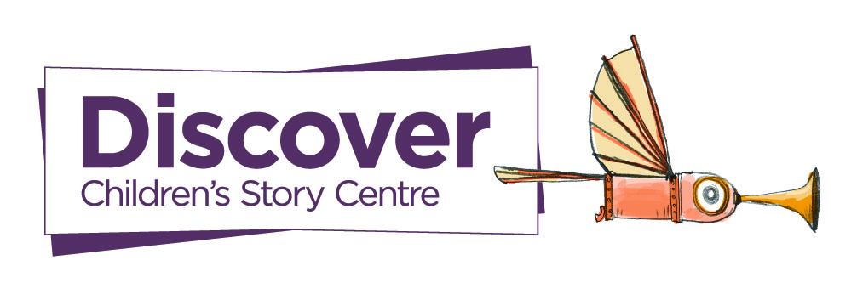
Discover, Children’s Story Centre | Story Suitcase Booking Form

Thank you for your interest in booking a Story Suitcase visit offered by Discover.
Please kindly fill in the form below, email to education@discover.org.uk, and someone from our team will get in touch shortly. Thank you!
- Name, your role at the school and email address
- Name of the school
- Address of the school
- How many full-day visits would you like to book?
(Please note, on a full-day visit, we can only offer up to three 60-minute sessions)
- Which year groups would you want us to visit and how many children are there per class? (Please note, that we can have up to 35 children per session)
- When would you like us to visit?
(Please provide specific months/weeks and if not, a range of available dates)

