Management of Coronavirus (Covid-19)  Within the Workplace | Assessed by: | Date: | Title of Assessment
 | PC | 01/08/20 | Management of Coronavirus (Covid-19) within the Workplace
 | RSG | 21/08/20 | Description of Task
 | Date to be reviewed | 04/09/2020 | General management of welfare and hygiene practices to prevent the spread of Coronavirus within the workplace.
 | Date of last review | 28/08/2020
 | Reviewed by | RSG / PC / KBB

Document Accepted By (Name) | KBB |  | Sign |  | Date |  |  | 02/08/20
Further Risk Controls Implemented By (Name) | RSG |  | Sign |  | Date |  |  | 02/08/20
 |  |  |  |  |  | S  e v e r i t y | 5 | 5 | 10 | 15 | 20 | 25
 |  |  |  |  |  |  | 4 | 4 | 8 | 12 | 16 | 20
RISK |  |  |  |  |  |  | 3 | 3 | 6 | 9 | 12 | 15
LIKELIHOOD |  | SEVERITY |  |  |  |  | 2 | 2 | 4 | 6 | 8 | 10
1. Extremely Unlikely |  | 1. Minor Injury/disease no lost time |  |  |  |  | 1 | 1 | 2 | 3 | 4 | 5
2. Unlikely |  | 2. Injury/disease up to 7 days lost |  |  |  |  |  | 1 | 2 | 3 | 4 | 5
3. Likely |  | 3. Reportable under RIDDOR Over 7 days |  |  |  |  | Likelihood
4. Very Likely |  | 4. Specified Injury/Long term absence |  |  |  | Low |  |  | Medium |  | High
5. Almost Certain to happen |  | 5. Death |  |  |  | 1-8 |  |  | 9-12 |  | 15-25

HAZARD | HAZARD LOCATION | WHO AFFECTED | INITIAL RISK |  |  | RISK CATEGORY | EXISTING RISK CONTROLS | FURTHER RISK CONTROLS NECESSARY | RESIDUAL RISK
 |  |  | L | S | R |  |  |  | L | S | R
Exposure to Coronavirus Leading to Related Ill- Health:  COVID-19: a respiratory illness caused by a novel coronavirus (SARS coronavirus-2 (SARS-CoV- 2)).  Symptoms may include a fever, cough, shortness of breath, breathing difficulties, Muscle Pain and Tiredness. | Discover | Staff  Visitors Contractors | 3 | 5 | 15 | High | Staff and Contractors  - Shaking hands with colleagues/visitors etc. to be avoided.  - Pregnant workers subject to a separate risk assessment.  - Workers are regularly updated and consulted on the current situation.  - Executive team to monitor ongoing external advice and feedback to business accordingly.  - Where practical workstations are adapted to provide greater spacing between workers.  - separating of business-critical teams into pods  - Identify and assess any vulnerable workers.  - Regular management meetings (held with social distancing in mind) to discuss ongoing developments and feedback to workers via email and other mediums which minimise social contact.  - Meetings via Teams or Zoom required wherever possible to encourage social distancing.  - All non-essential business travel has ceased within the UK and abroad.  - Workers instructed in good personal hygiene practice.  - Managers are instructed on how to respond to an employee/visitor displaying symptoms of Covid-19. Individual to be sent home to self- isolate.  - Workers are required to follow current government guidance and self-isolate for 14 days from the day when the first person in the household fell ill (when living with others).  - If a member of staff has helped someone who was taken unwell with a new, continuous cough or a high temperature, they do not need to go home unless they develop symptoms themselves. They should wash their hands thoroughly for 20 seconds after any contact with someone who is unwell with symptoms consistent with coronavirus infection.  - Self-isolation periods for affected individuals (who live alone) should follow current Government advice.  - Guidelines issued to staff prior to returning to the workplace.  - Office rota created to reduce capacity, hotdesking possible, all items removed from desks to enable cleaning. Kitchen one person at a time  - Staff areas closed off and alternative lunch area provided  - Revised risk assessments from contract cleaners.  - Where workers are to work from home request they complete a self DSE assessment; provide appropriate DSE facilities such as laptops/screens.  - Shifts staggered where possible to minimise staffing contact.  - Identify any opportunities for ‘mental’ health support for workers.  - Provide remote (off site) workers with appropriate guidance and hygiene facilities e.g. sanitizers and moisturisers.  VISITORS  - Additional hand washing provision in place at the premises. Soap and sanitisers provided via pump dispensers.  - Warm air-drying units removed in bathrooms.  - Toilets converted to accommodate 1 family group at a time with locking mechanisms on main doors.  - Visitors and contractors strictly limited on site; Business critical support only; early contact made with those who are required to avoid visiting the premises.  - 3 x Family Sessions per day with limited numbers of visitors per session  - Tickets only available for purchase online and can be print at home or shown as e-ticket  - Track and trace will be followed by collecting customer details during the booking process. These are stored securely and comply with GDPR.  - Cleaning schedule after every family session  - Small play items reduce in number and strict rotation of items in place in between sessions  - Items that cannot be disinfected to be quarantined  - Deep clean each evening  - Waste bin bags containing tissues/cleaning waste are securely tied and removed by workers wearing disposable gloves  - Provision of disposable tissues around site; bins provided in which to place used tissues.  - Any surfaces recently contacted by affected individuals to be isolated and thoroughly cleaned in line with current guidance at: https://www.gov.uk/government/publications/ covid-19-decontamination-in-non-healthcare- settings/covid-19-decontamination-in-non- healthcare-settings  - Provide instruction and training to people who need to clean. Include information on:  the products they need to use  precautions they need to follow  the areas they need to clean  - Branded posters on effective hand washing placed around site and at wash areas.  - Increased hand washing advised to all workers and permitted visitors (wash for a minimum of 20 seconds).  - Screens installed at reception  - Contactless payment at FOH to reduce cash handling  SCHOOLS  - While operating the timed, capacity-limited visiting structure, schools only admitted for 10am – 12pm sessions.  - As per the cleaning schedule above, spaces used for school activities (Basement, Exhibition, First Floor Story World) deep cleaned the evening before and surface clean and refresh of materials done at the end of the school visit.  - School class sizes remain max. 30 children. Double class bookings admitted for Exhibition visits only.  - Schools asked to reduce the number of accompanying adults, to the minimum necessary. Additional carers and/or parents permitted to accompany groups if required to meet school risk assessment needs.  - School groups have exclusive, timed use of the Basement when visiting for Exhibition free play and workshop activities. Family visitors able to access the Ground Floor and First Floor Story Worlds when a school is visiting the Exhibition.  - Belt barrier and signage placed at the top of the stairs to basement to close space off to family visitors during Exhibition school visit.  - Story World school sessions only booked on days when schools are visiting the Exhibition as well. Story World school groups have exclusive use of the First Floor Story World and no Family visitors will be admitted during the 10am – 12pm period if a Story World school session is taking place. This is a temporary measure to minimise risk of family and school groups mixing due to the open access between ground and first floor via the stairway.  - Hand sanitation equipment provided for school groups upon arrival.  - Story Builders wear visors while facilitating school workshops and maintain 2m distance from group, where possible.  - Craft and drama materials used for school workshop refreshed for each workshop. Used materials put into quarantine after use.  - School lunching not accommodated. Schools informed prior to visit in pre-visit information.  - Teacher site visits only pre booked with Education team to reduce too many people in the building. | - Identify and assess any vulnerable workers. | 2 | 5 | 10

Symptoms:
The following symptoms may develop in the 14 days following exposure:
- Cough
- Loss of taste or smell
- Difficulty Breathing
- Fever
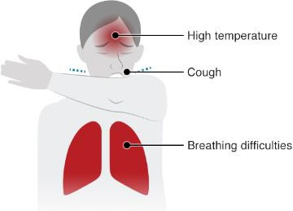

- Sensitivity: Effects may be increased and more severe in people with weakened immune systems, older people, people with diabetes, cancer or chronic lung disease.

- Spread: Transmission can happen if either of the following occurs:

  - People in close contact (within 2 meters) of an infected person allowing inhalation of virus into the lungs from coughs and sneezes.

  - Touching a surface, object or hand of an infected person that has been contaminated with respiratory secretions from an infected person then touching own mouth, nose or eyes.

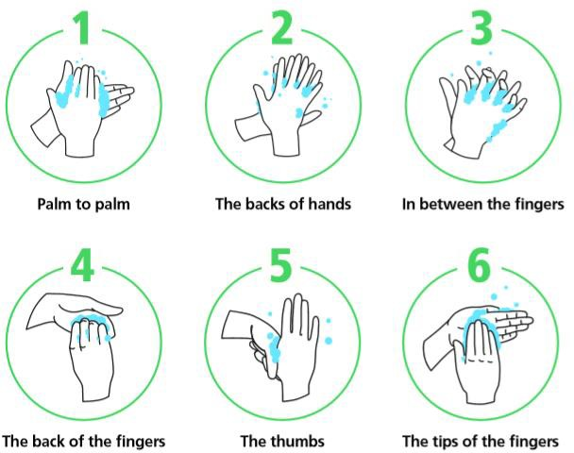
Control Measures
- Update: The company will keep updated on latest Government guidance and update policies and procedures accordingly.
- Hygiene: Ensure you wash hands regularly for 20 seconds with hot water and soap:

- Catch it, Bin it, kill it: cover your mouth and nose with a tissue or your sleeve (not your hands) when you cough or sneeze.
- Self-Isolation: Ensure you follow the Gov/NHS guidance for self-isolation where required if you have either:
  - A high temperature
  - A new, continuous cough.
Information: If you require any further information or have any concerns speak to a member of management immediately.

Management of Covid-19 Within the Workplace Version 01 17/03/2020 Confirmation of Employee Understanding of Risk Assessment and Safe System of Work

Name | Signature | Date

